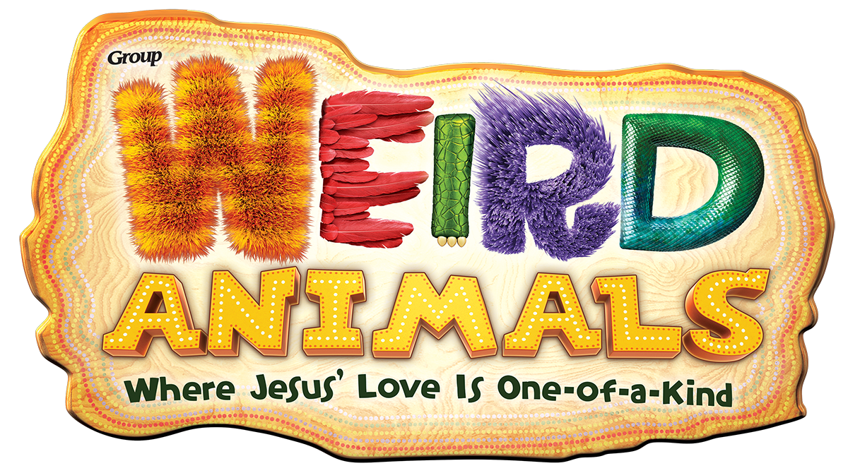
SNACKS!
Information for participants with food allergies

Each day during our adventure we will offer a snack. Listed below are the ingredients for each day. If your child is unable to eat the daily snack due to its ingredients, please send in a snack for him or her to have. *ALL SNACKS SENT IN SHOULD BE BAGGED AND LABELED WITH YOUR CHILD’S NAME, GRADE, and GROUP ASSIGNMENT.* Example: Lucas Jones, 2nd Grade Yellow Shred

Water will be offered along with the snack every day.

Please drop off your child’s labeled snack in the ENTRY each morning. A staff member will take it to the kitchen for you. Our kitchen staff will have a list of all children with food allergies.
Please speak with the director, Jennifer Bloss, if you have any further questions or concerns. We want your child to have a safe, fun experience during our time in the kingdom!

Ingredients by Day:
*Please note that brands may vary unless a specific brand is noted*

Monday –Yogurt parfaits – vanilla yogurt, mandarin oranges, blueberries

Tuesday – Bagels (we will offer plain and with cream cheese), raisins

Wednesday – air popped popcorn

Thursday – Pretzel sticks, melted white chocolate, grapes

Friday – “ice cream cone” cupcakes (Vanilla cake mix baked in an ice cream cone), cool whip, yellow sprinkles

If your child is in the PreK class, they are offered a simpler, bagged alternative on some days. Those are as follows:

Monday: Animal Crackers
Thursday: pretzel sticks and grapes
Tuesday: Teddy Grahams
Friday: “ice cream cone” cupcakes (as above)
Wednesday: Popcorn (as above)

